Options to install kubernetes

1. AWS
2. Google

NOte : Run cmd in administrator

To install kubectl utility(works on kubernetes installation, Cloud-netral also)

https://kubernetes.io/docs/tasks/tools/install-kubectl-windows/
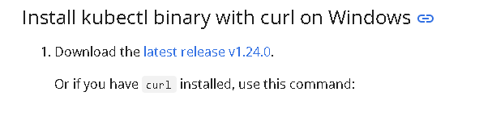
To check whether is installed or not
On cmd
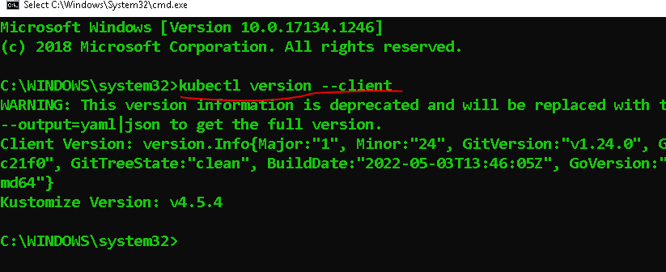

Download and Install Minikube

Go to
https://minikube.sigs.k8s.io/docs/start/
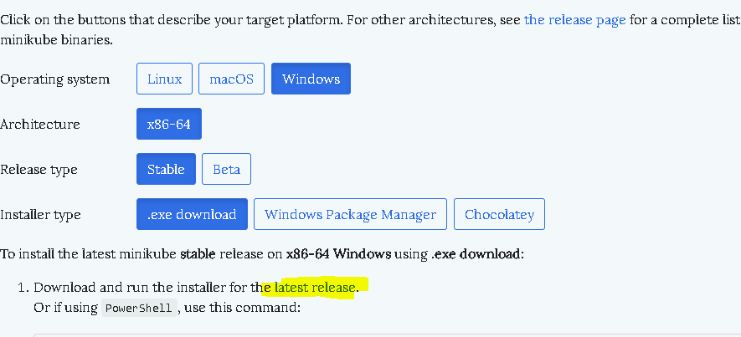
To check whether is installed or not
On cmd
Note: Go to that folder where it is installed and run cmd OR add path in the environment variable of that .exe file.
>systeminfo
>minikube start
(Open docker first then use minikube start cmd)
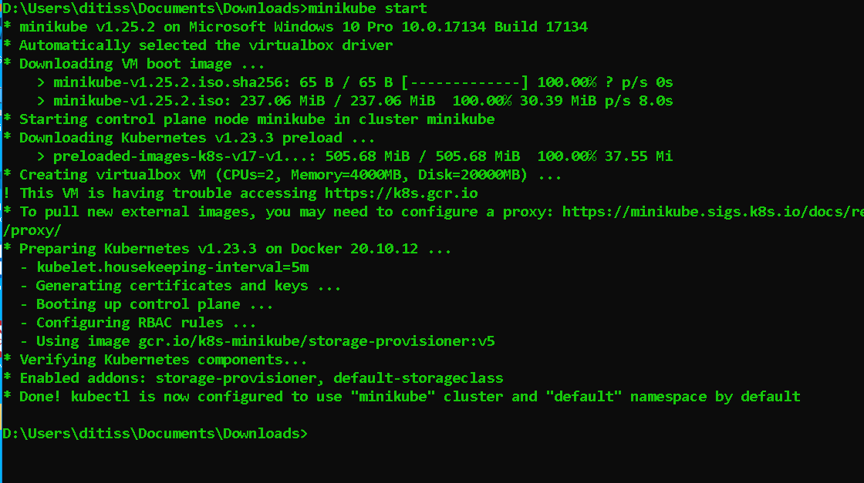

Note :If still it works then use below cmds to download drivers
minikube start - -driver vmware
minikube start - -driver HyperV

Then check whether kubectl is working or not
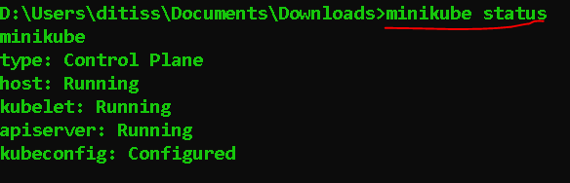

To check nodes info
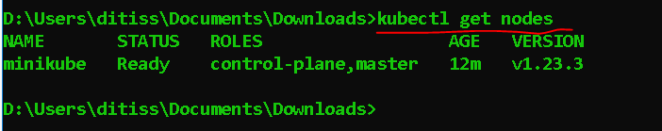

On cmd to create
>kubectl create deployment hello-node --image=k8s.gcr.io/echoserver:1.4
https://kubernetes.io/docs/tutorials/hello-minikube/
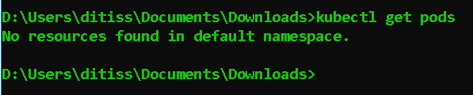

To deploy
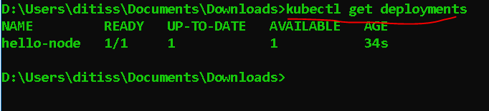

To check Pod info
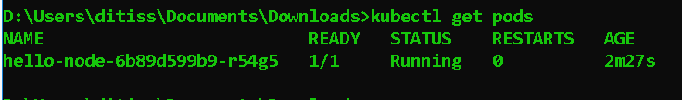

Expose/ Host the deployment as a service
>kubectl expose deployment hello-node --type=LoadBalancer --port=8080

To get ip Address for minikube
Go to browser and
http://192.168.59.100:30784
